



Información extra

**Título del documento**

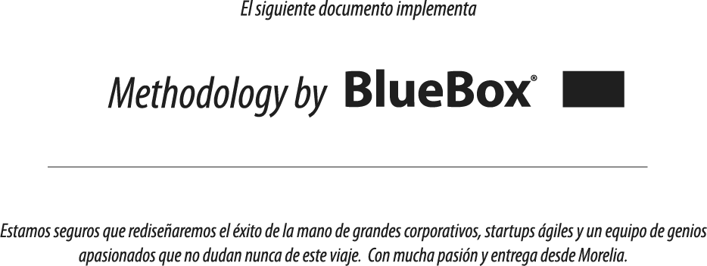

**Page 3** Environmental Responsibility at BlueBox

**Page 5** Climate Change

**Page 19** Resources

**Page 35** Safer Materials

**Page 42** Better Together

**Page 47** Appendix A

*Apple’s Operations: Environmental Data*

*Facilities Environmental Performance Indicators*

*Product Environmental Performance Indicators*

*Scopes 1 and 2 Carbon Emissions Breakdown*

*Fiscal Year 2017 Natural Gas and Electricity Use*

**Page 52** Appendix B

Data Center Energy Supplement

**Índice**

**Temario**